ISO 31000 Advanced Course – 4 - 8 November 2024 - Antwerp

Total Respect Management Academy – High Performance & Sustainability Programma

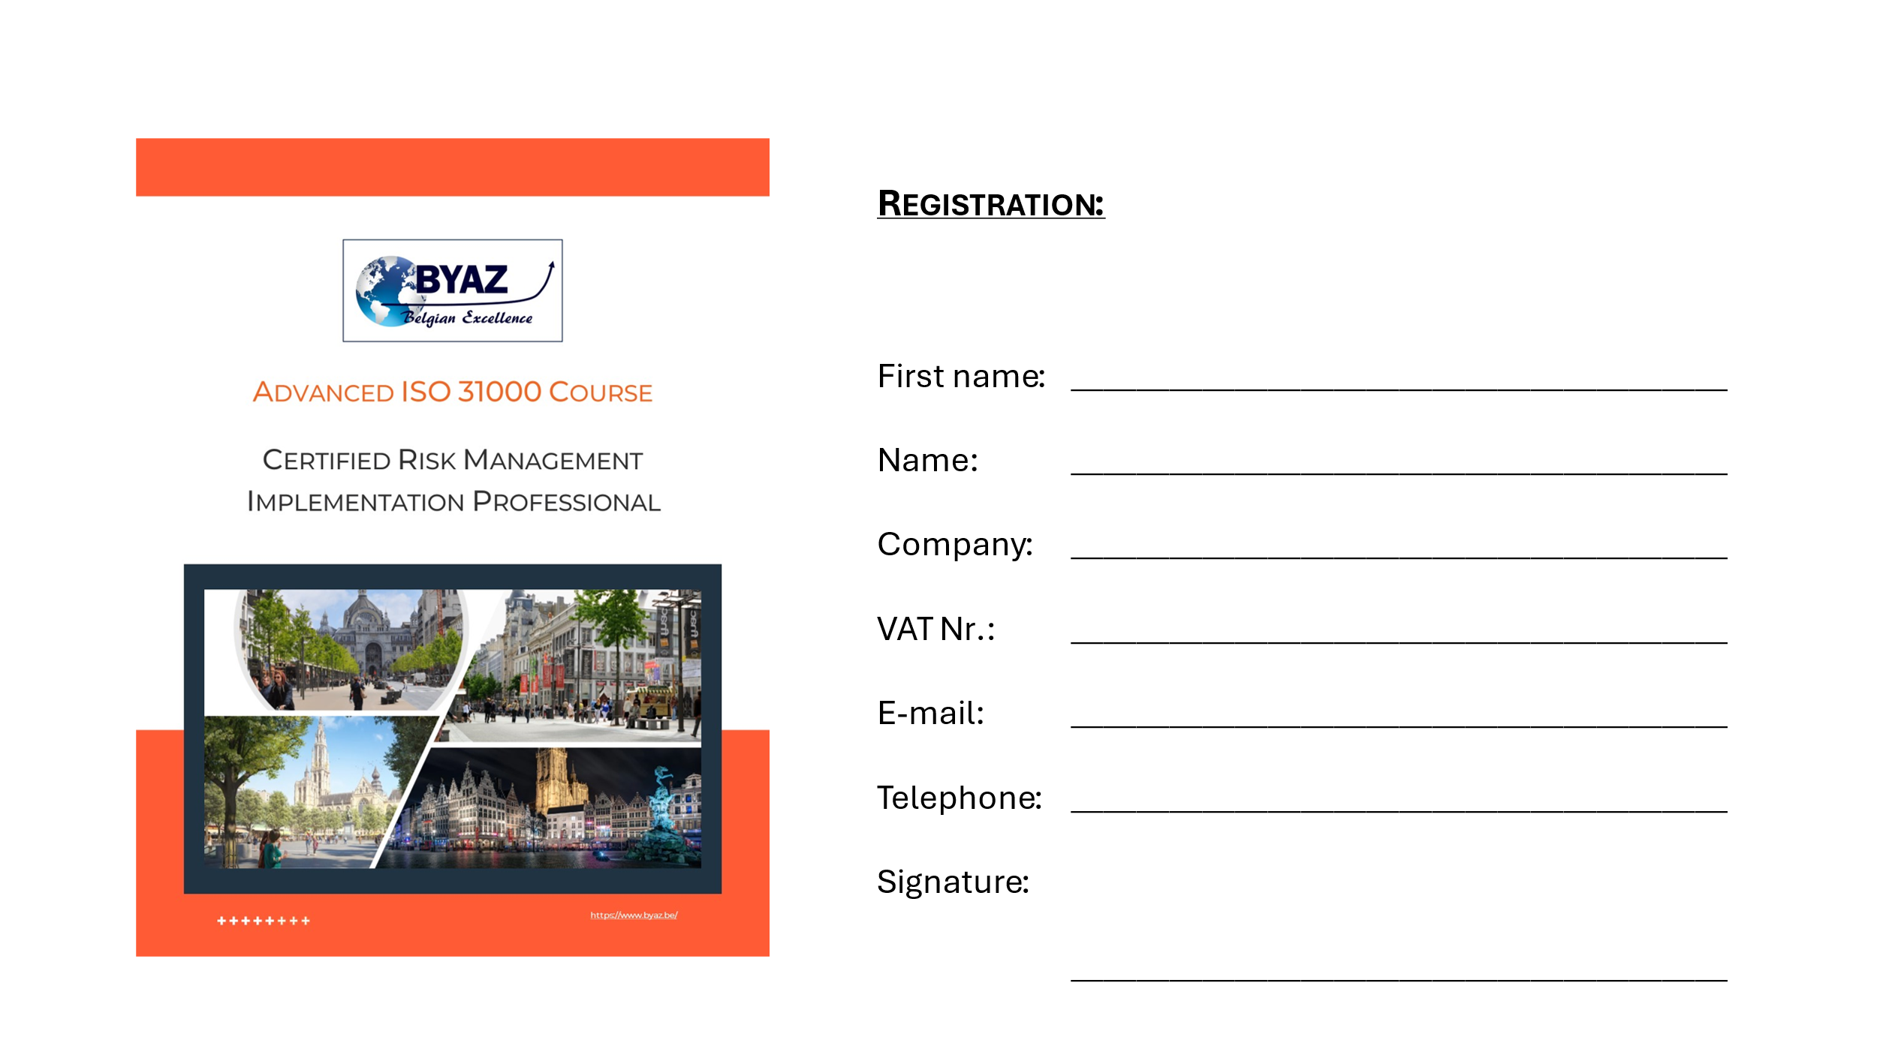
Please fill in and email to shop@byaz.be 16th of November 2024 at the latest!

